**PINTEREST**

**WEB APPLICATION**

**Pinterest is an image sharing and social media service. It is designed to enable saving and discovery of information in the internet using images, on a smaller scale, GIFs and videos, in the form of pinboards.**

**1.After opening the pinterest website we can login or sign up to further access the applications of it.**

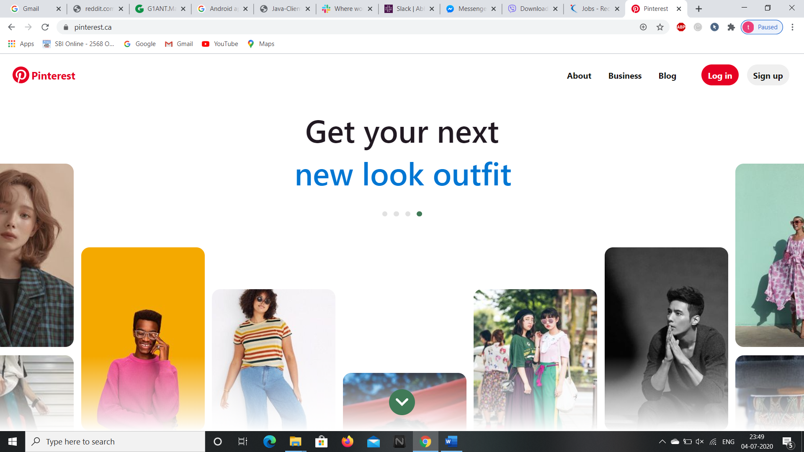

**2.After logging in, the home page is opened with the recent images we have viewed or recommended for you.**

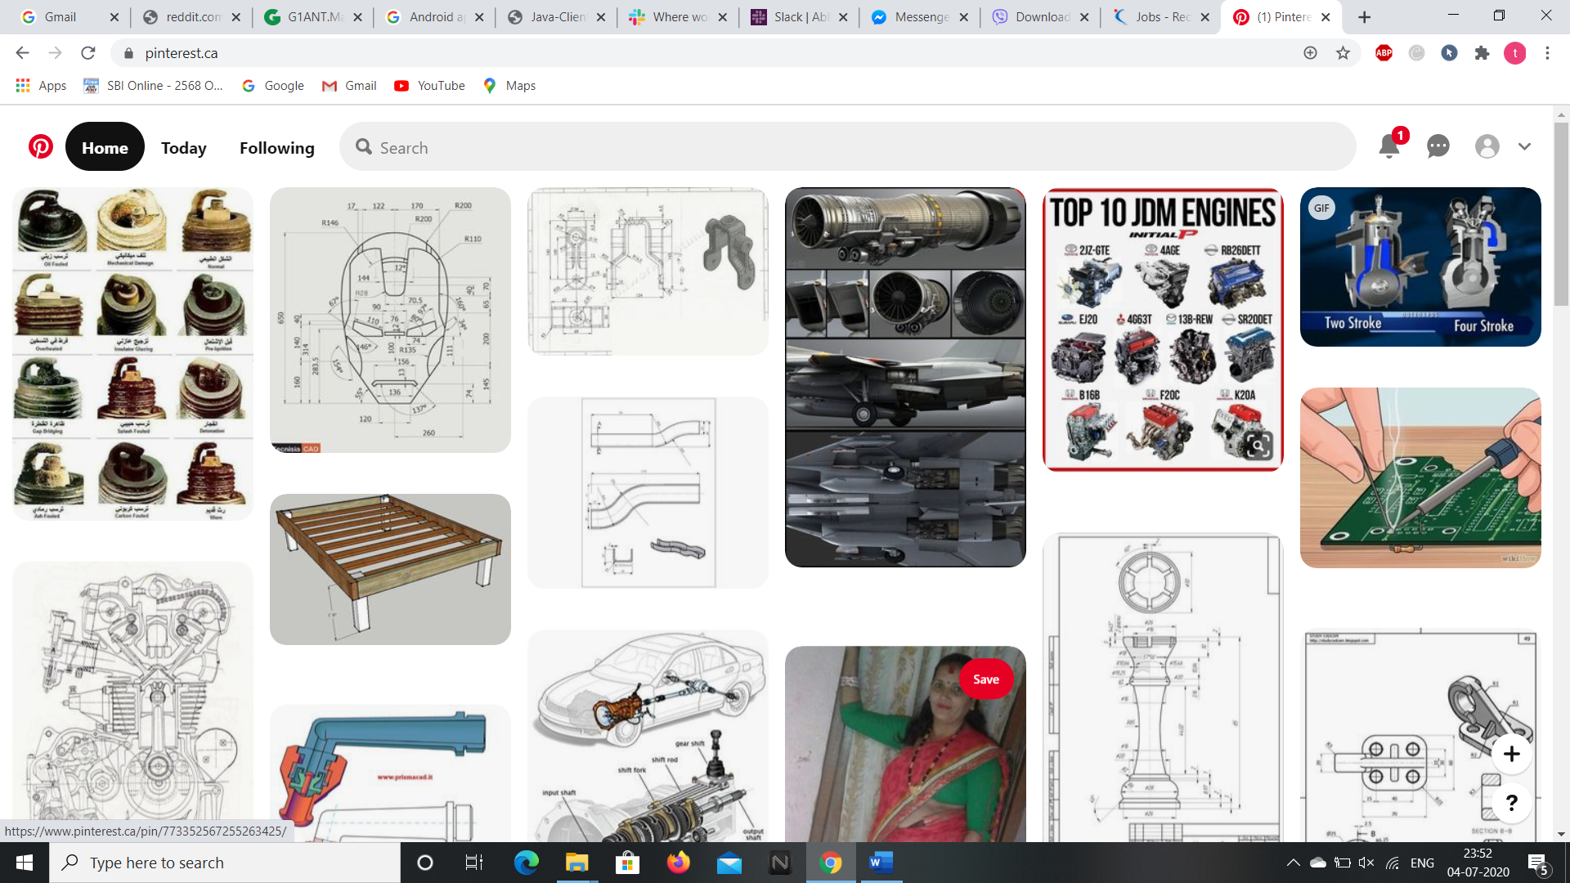

**3.By clicking on “Today” button on the left corner we can view the trending images of the website.**

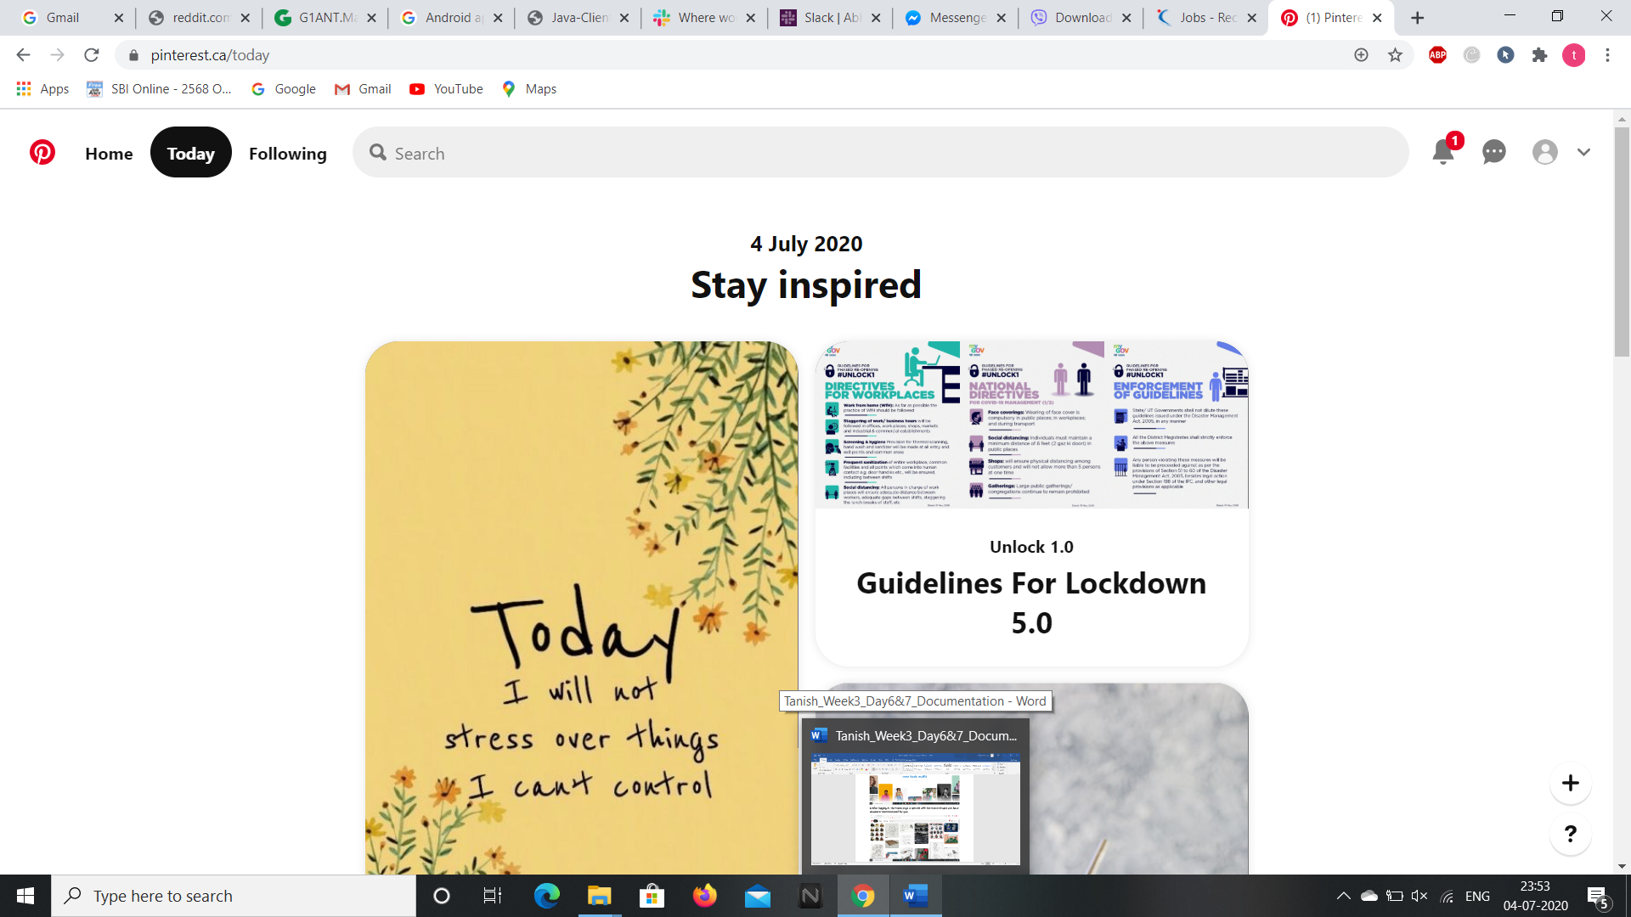

**4.By clicking on the “Following” option we can view the images of the members you have followed.**

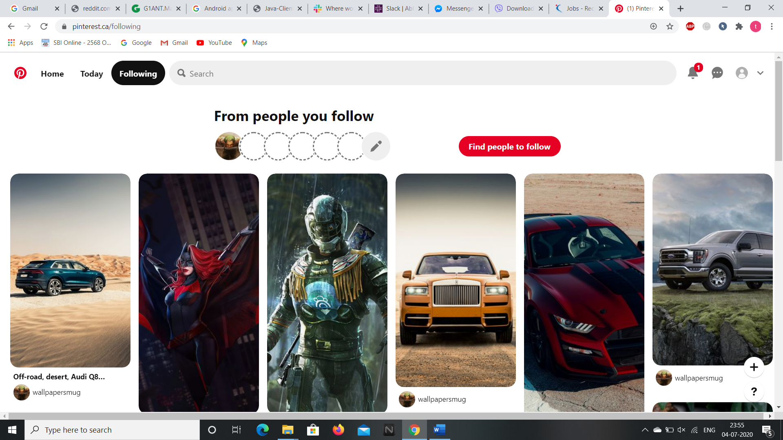

**5.By clicking on the “Bell” icon at the top right corner we can see the updates and notifications.**

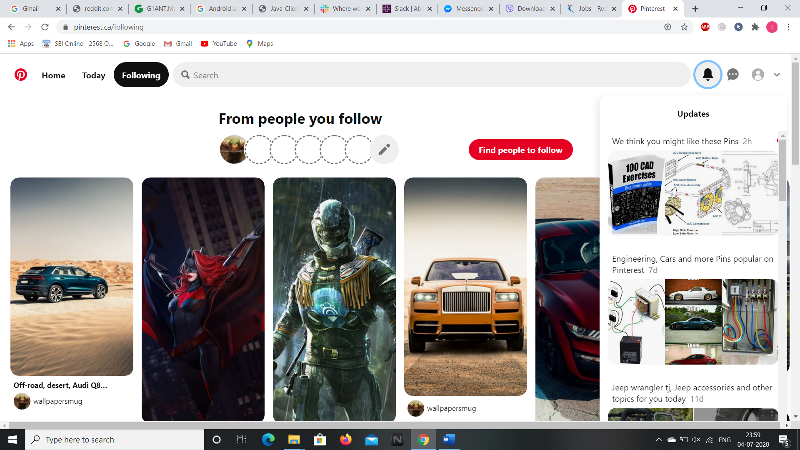

**6.The chat box button at the top right corner allows us to share our images or ideas or messages with our friends.**

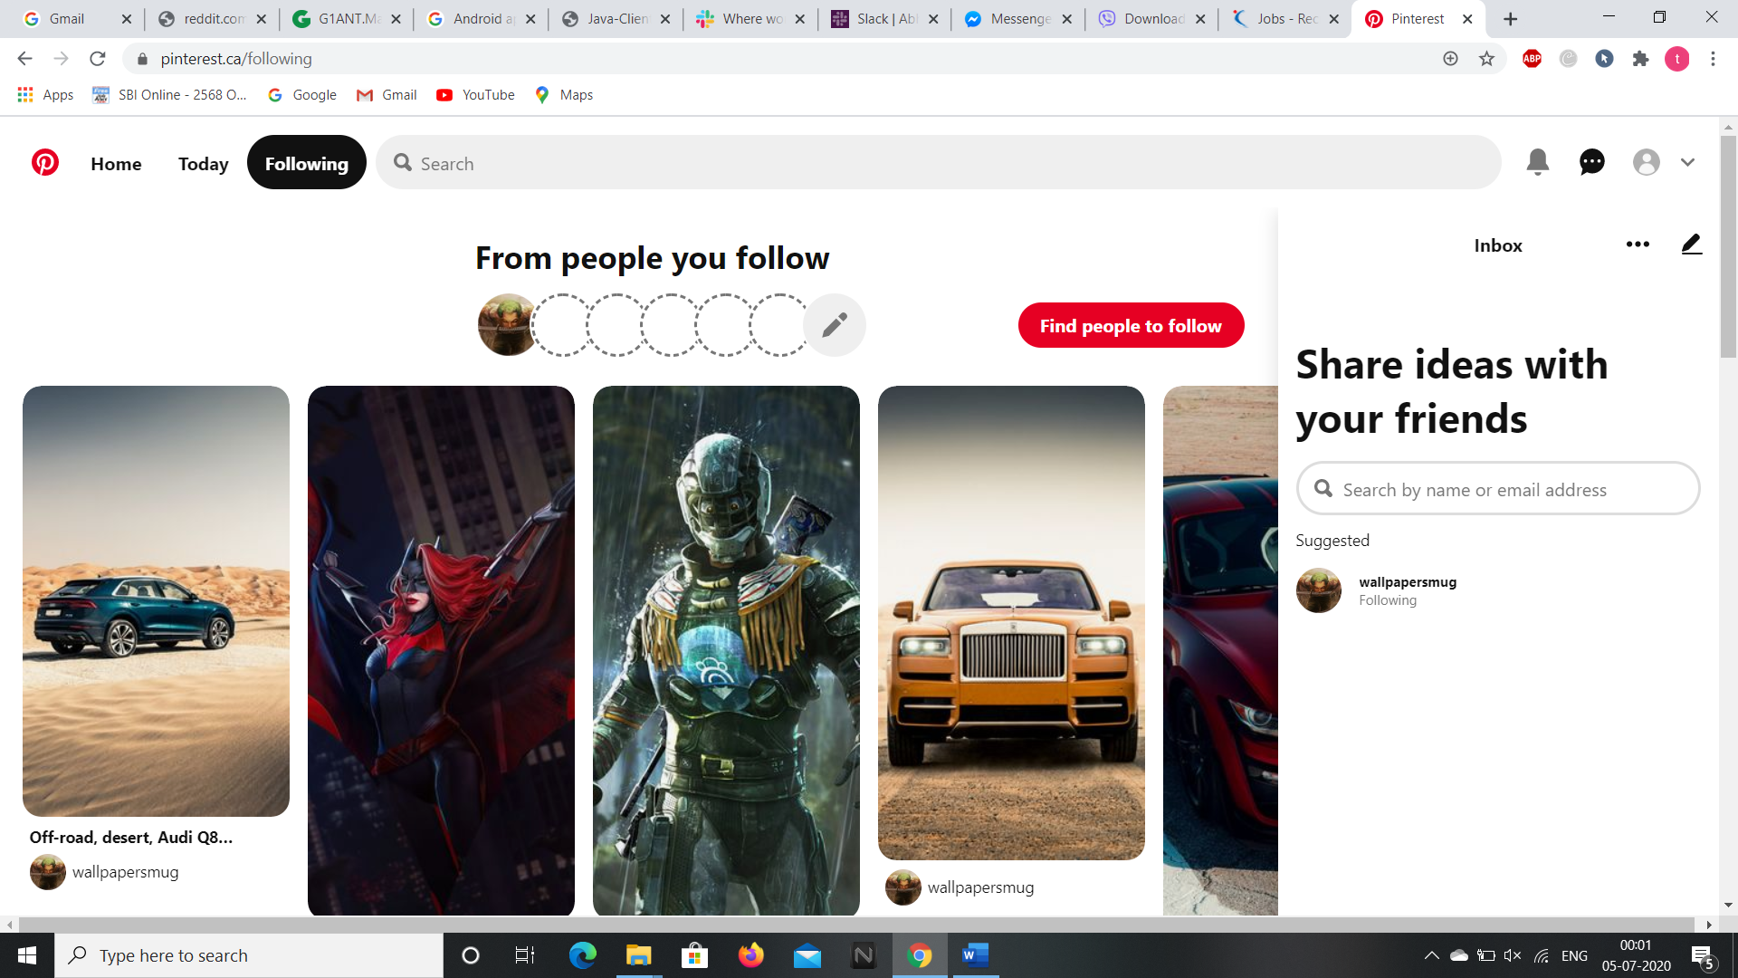

**7.The profile icon allows us to view the pins, boards, tries and topics.**

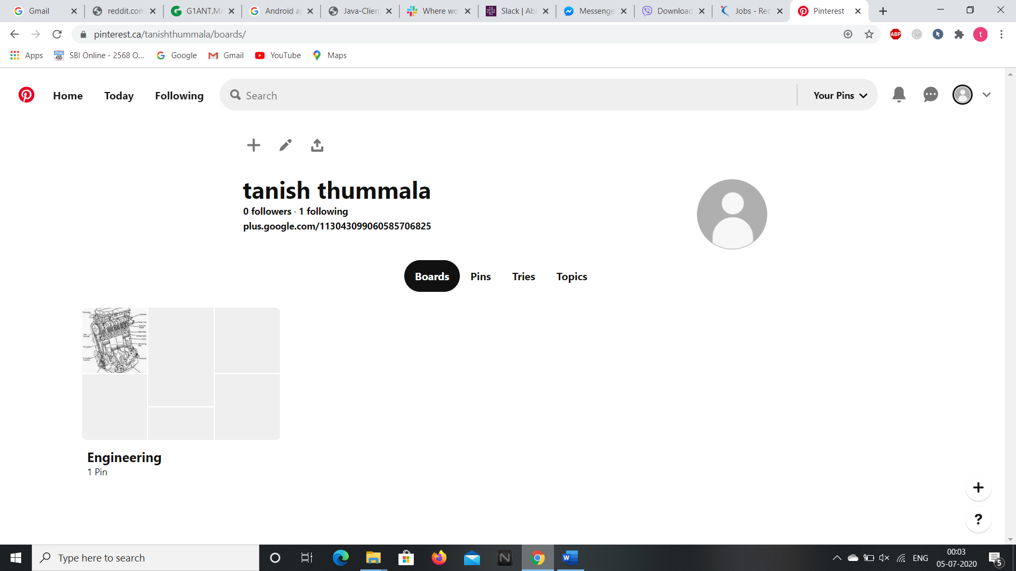

**8.By clicking on the drop down arrow we can access our account details and logout.**

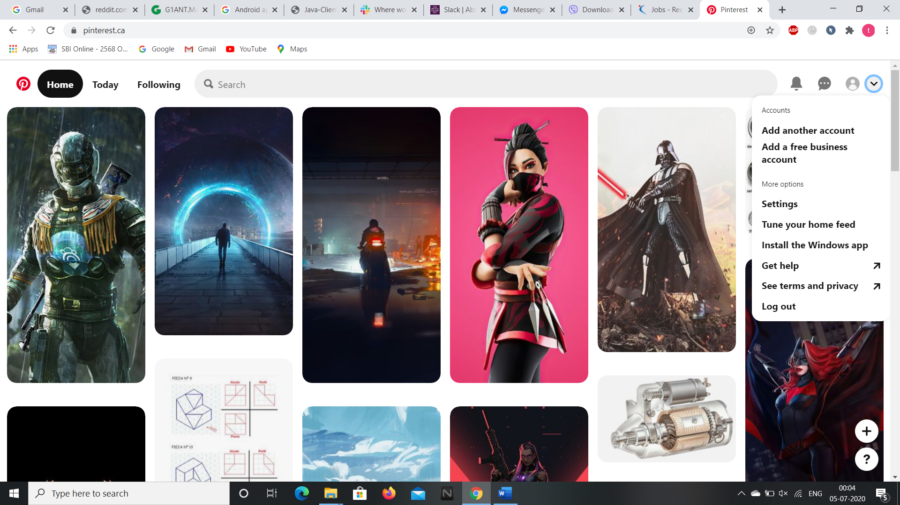

**So these are the contents present in the pinterest website and we can access the webpage through selenium addon as well. Now, let’s see the android application of it.**

**ANDROID APPLICATION**

**We can download the android application through “Google Play Store” and installing it in the Virtual Phone through Android Studio.**

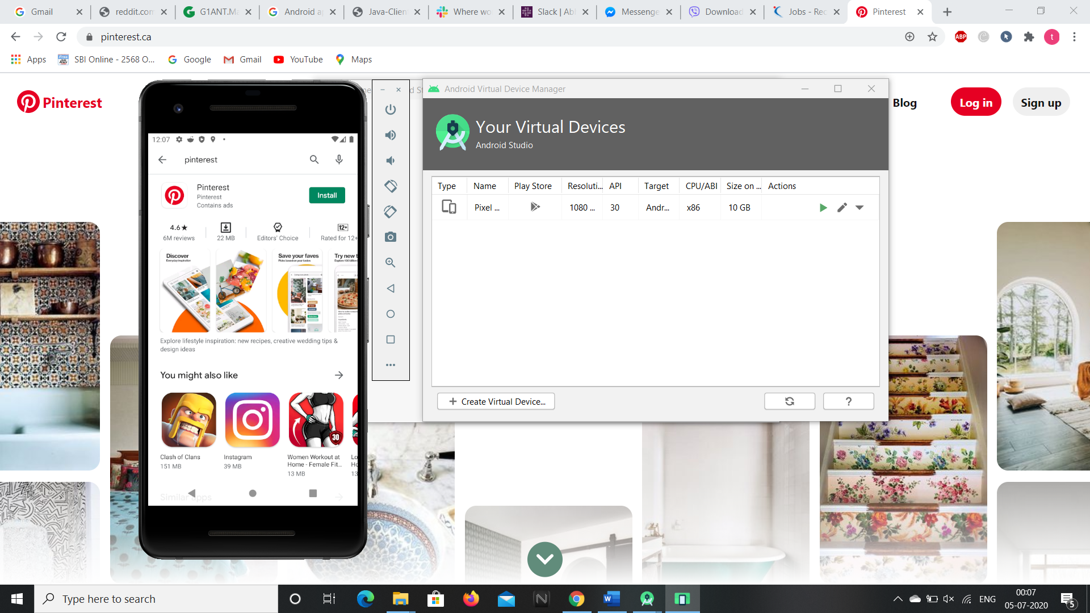

**1.After installing and opening the app, it asks to sign up or login if you have already signed up then login to pinterest community.**

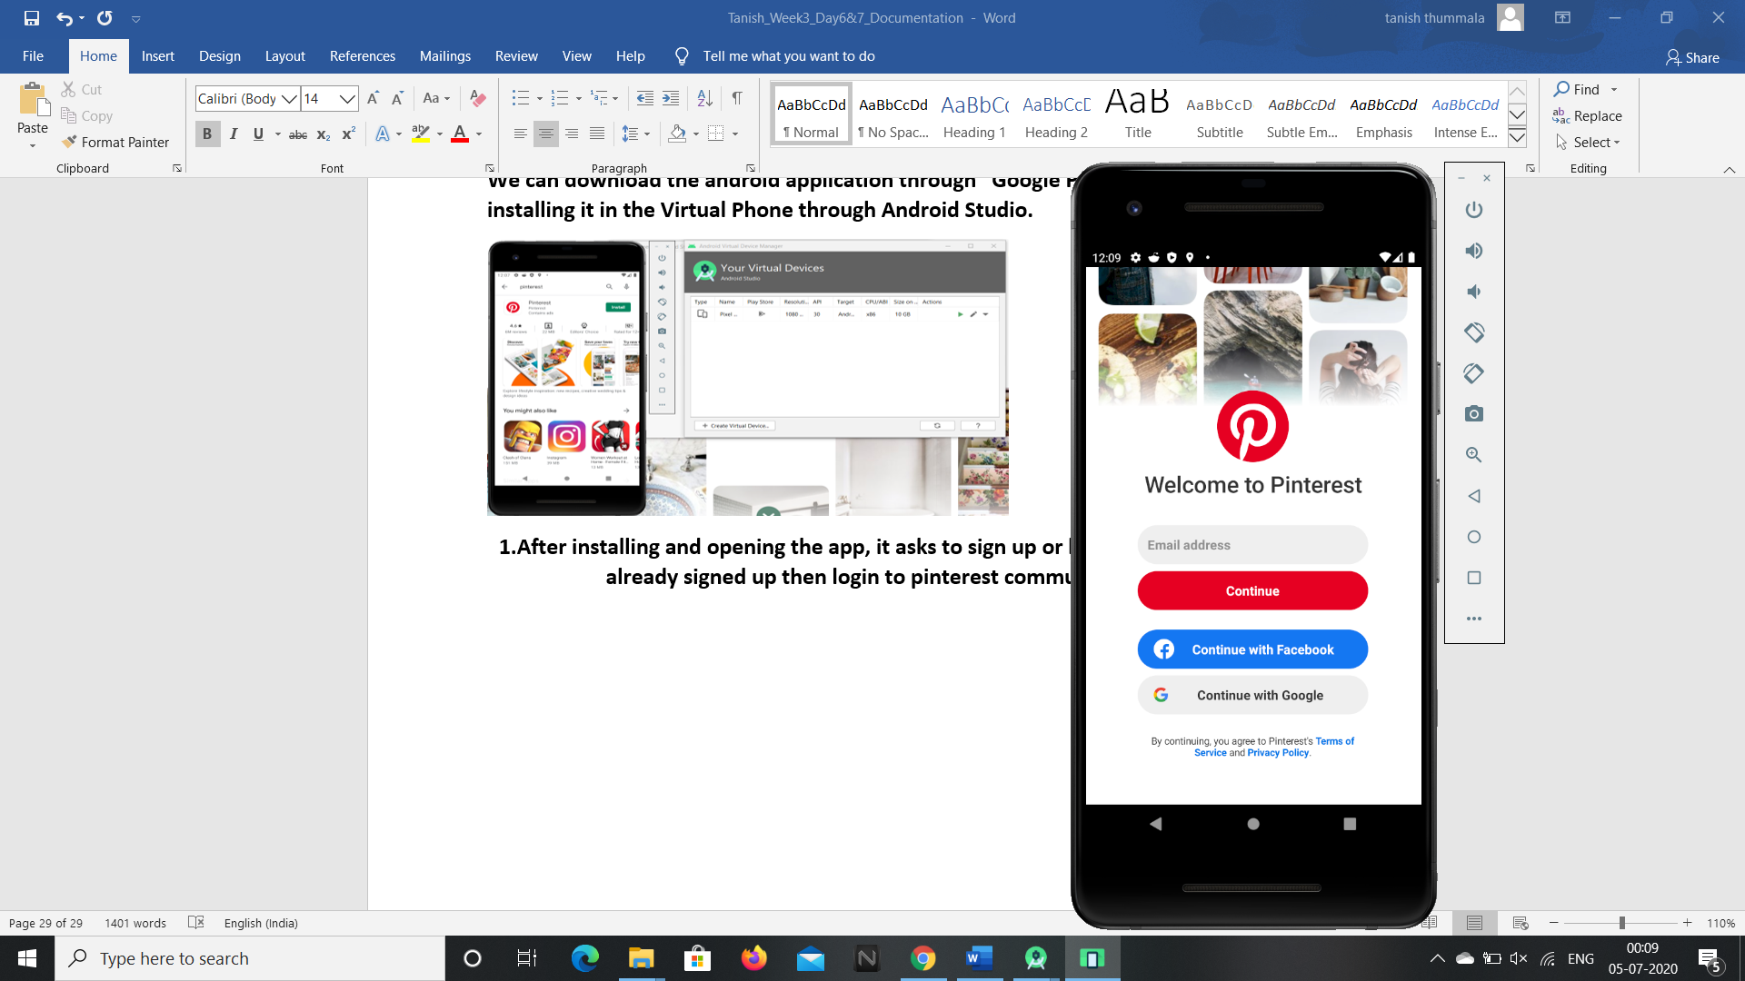

**2.Then we are redirected to the home page of the pinterest home page.**

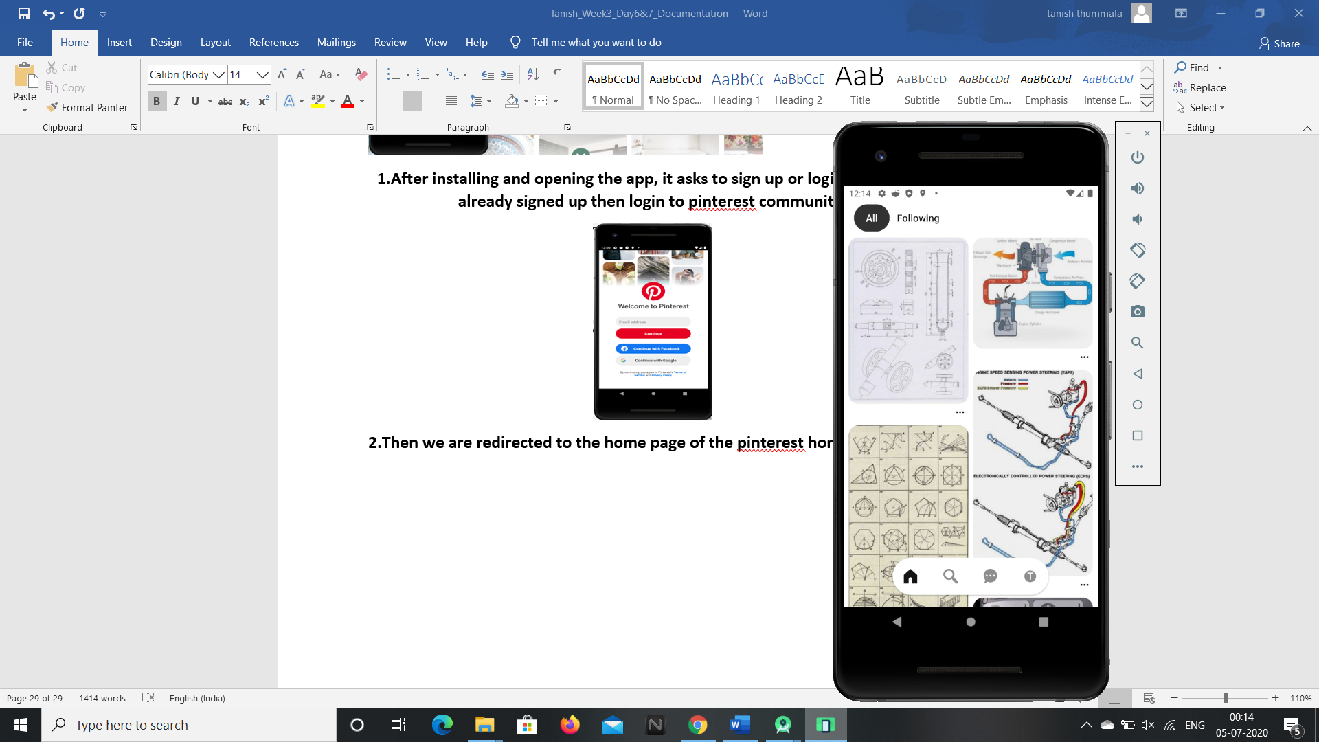

**3.By clicking on the “Following” option we can access the images of the member we have followed.**

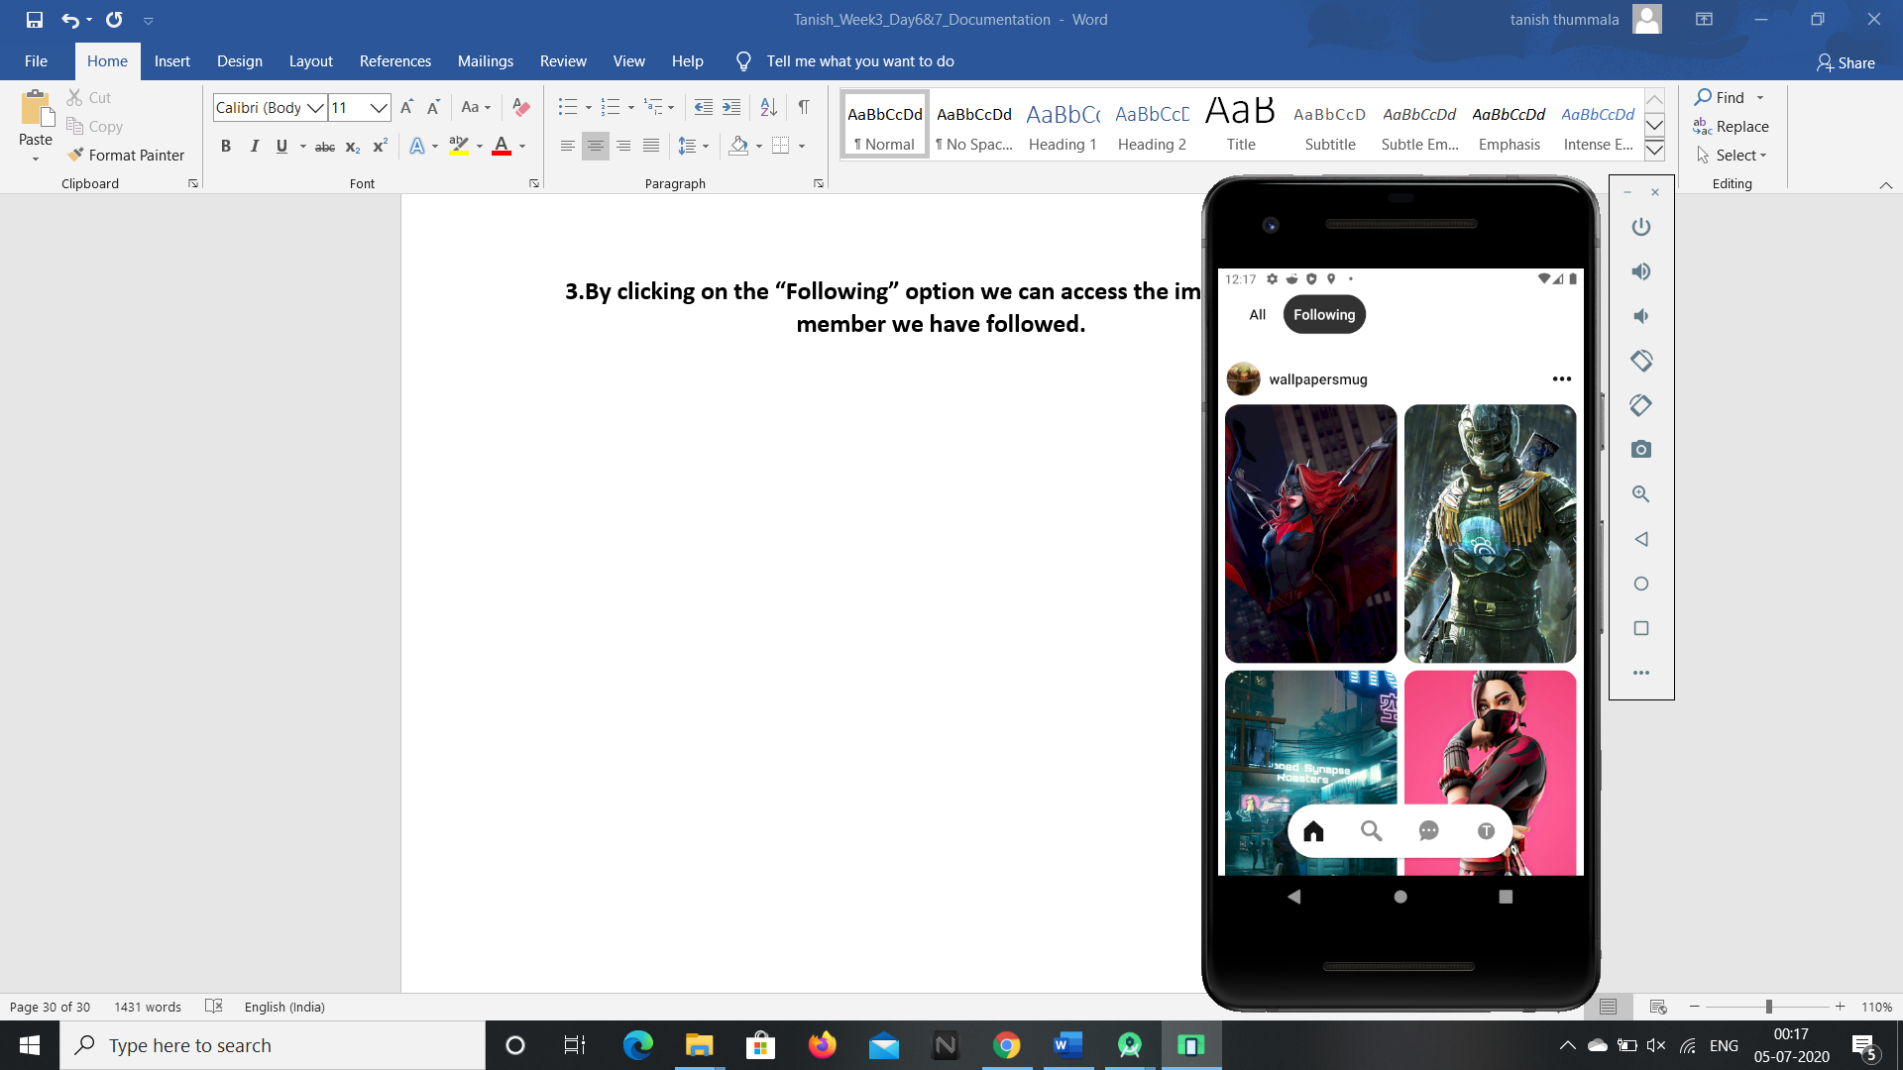

**4.By clicking on the search icon button at the bottom of the screen we can search the images or ideas that are required for us.**

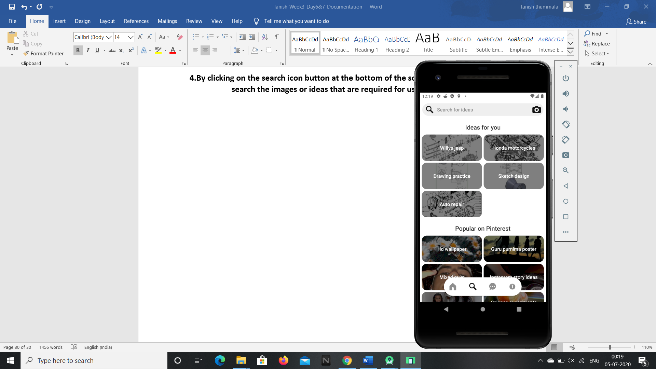

**5.By clicking on the chat box icon we can view the updates and the inbox.**

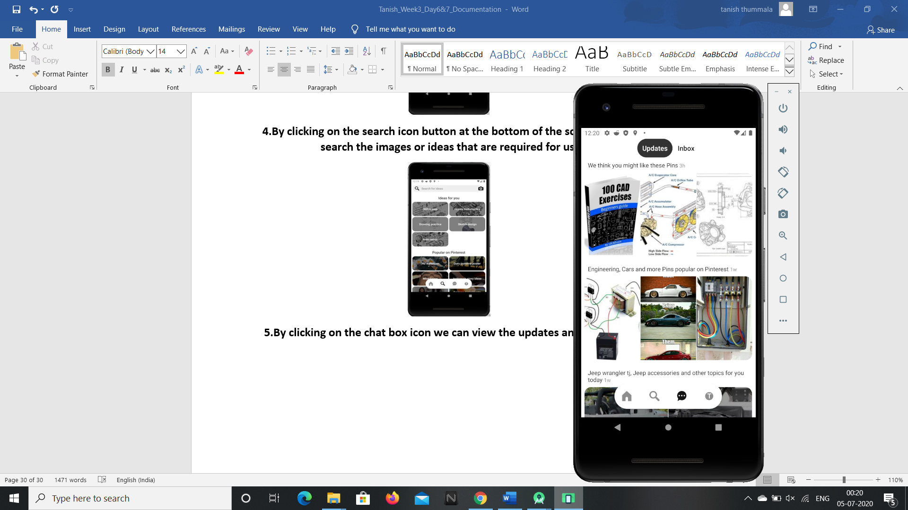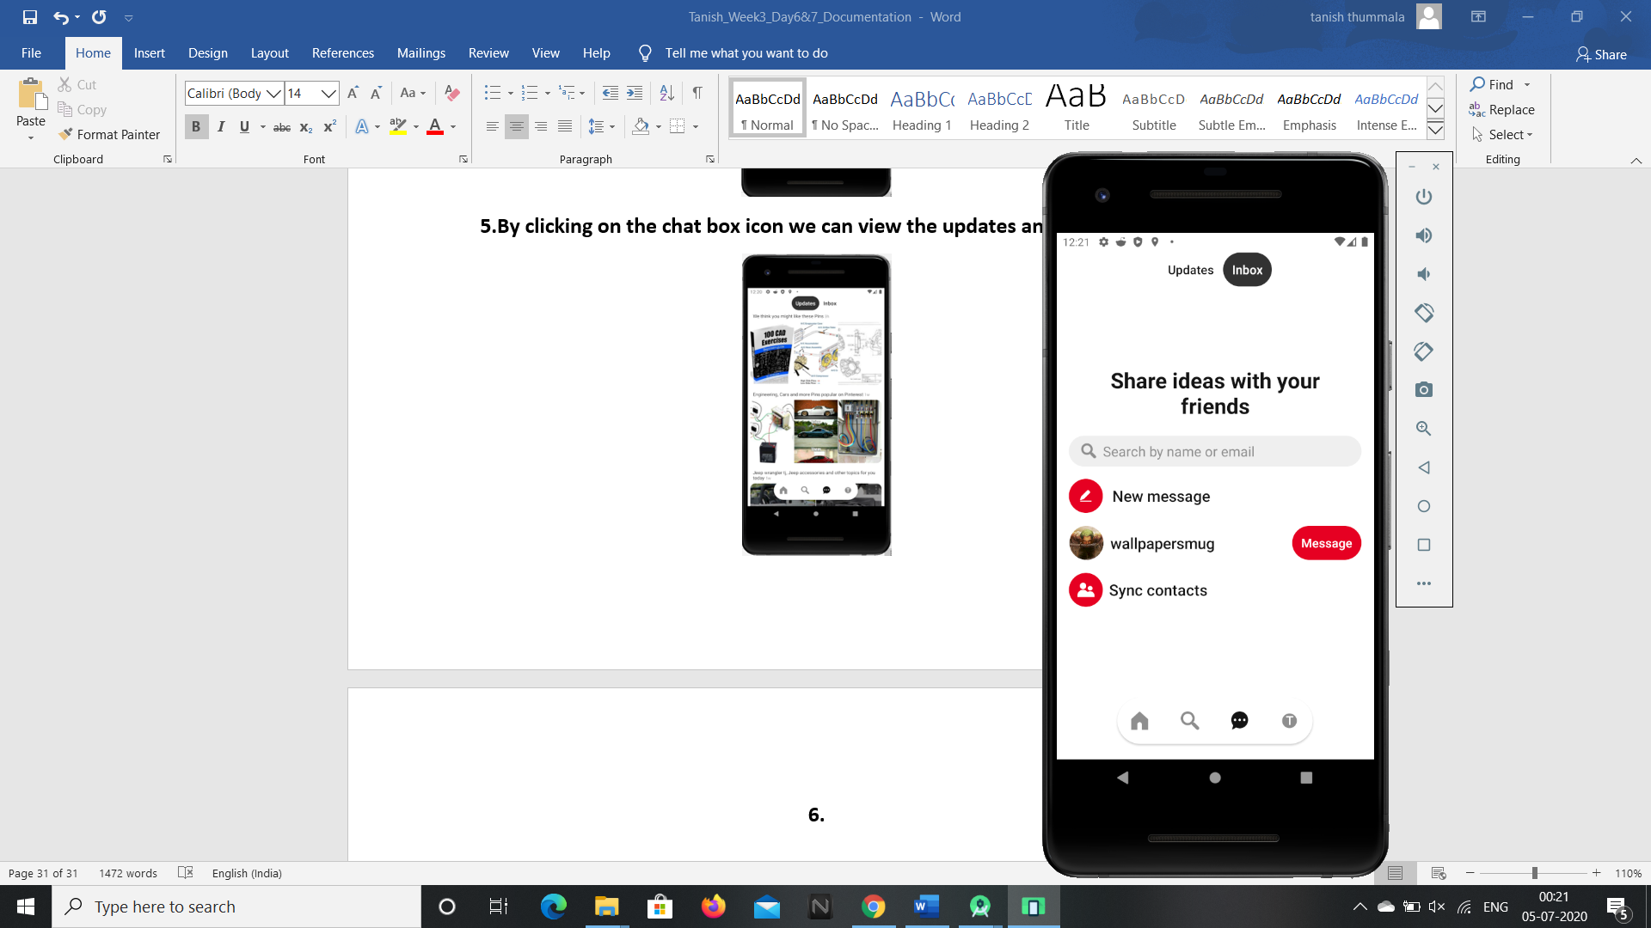

**6.By clicking on the last icon on the bottom dialog box we can view the boards, pins of our profile.**



**So these are the features present in the pinterest android application and these can be accessed by G1ANT Robot through Appium addon.**